Lab3 : Application and Data Analysis of High-Precision Receivers
By Dongkai YANG, Dayu YAN and Wasiu Akande AHMED

General Introduction
Satellite acquisition and tracking are fundamental processes in Global Navigation Satellite Systems (GNSS) that ensure accurate positioning, navigation, and timing (PNT) services. Acquisition involves detecting satellite signals and estimating their parameters, while tracking refines these estimates for continuous and precise measurements. This lab provides hands-on experience with satellite acquisition and tracking techniques, essential for GNSS applications in geolocation, surveying, and aerospace navigation.
Objectives
- Understand how to read data from the navigation message.
- Understand how to use high-precision receivers and RxTools.
- Learn to decode RINEX data and NMEA data.

Lab Equipment
- Septentrio-Mosaic High-Precision Receiver with antennas
- MATLAB code for signal processing
- Sampled data for testing

1 Equipment and Setup
- Make sure you have all the equipment and accessories shown in Figure 1.
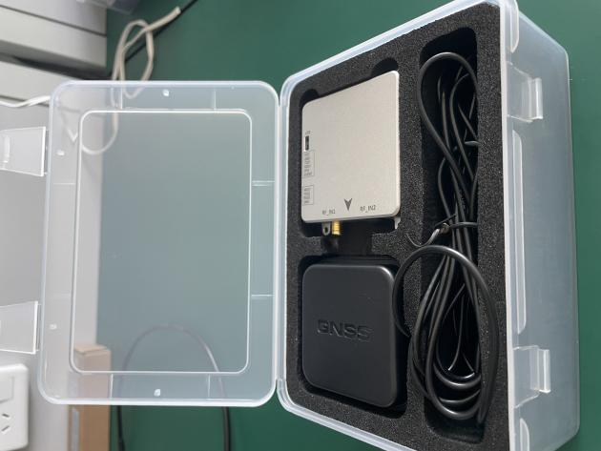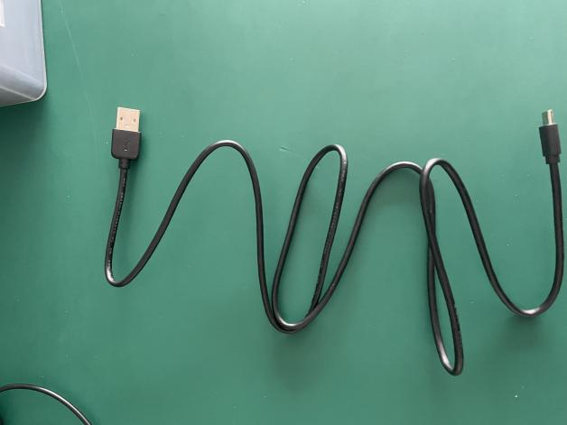
Fig.1 High precision receiver kit and USB cable

- Connect the antenna and power/data cable to the receiver as shown in the Figure 2. NOTE: Place the antenna horizontally on open and spacious surfaces such as tables, otherwise it may affect the signal strength. If the connection is successful, the sampler will have the purple lights stay on.
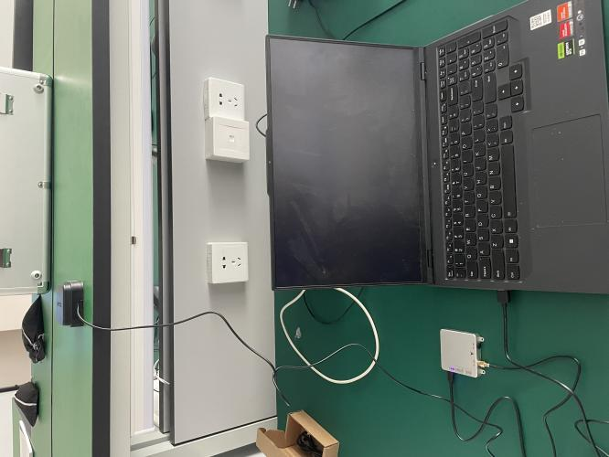
Fig.1 Equipment Connection

- Install RxTools using “rxtools_24_0_0_installer.exe”. After the software installation is successful, the following set of programs will be available:
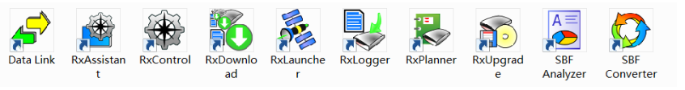
- Host computer debugging software: RxControl
- Serial port debugging tool: Datalink
- Firmware and license upgrade program: RxAssistant
- SBF data analysis program: SBF Analyzer
- SBF conversion program: SBF Convertor
- Data recording program: RxLogger

- Launch the RxControl software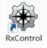, and a Connection Setup dialog box will pop up. Select Serial Connection/Create New... For the first connection, a new one needs to be created; for subsequent connections, simply select the existing serial connection that has been created.

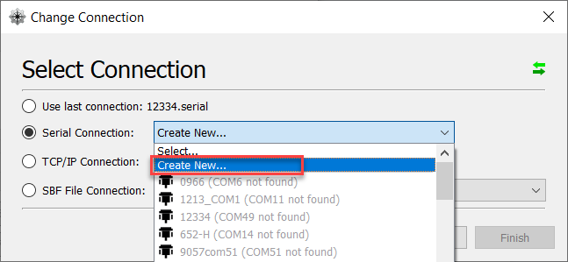

Select the corresponding serial connection and define a name for this connection. Note that the name should not directly use the serial port number.

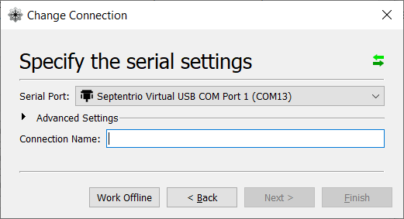

After a successful connection, the interface of RxControl will be displayed as shown below, allowing you to directly check the status of the satellites.
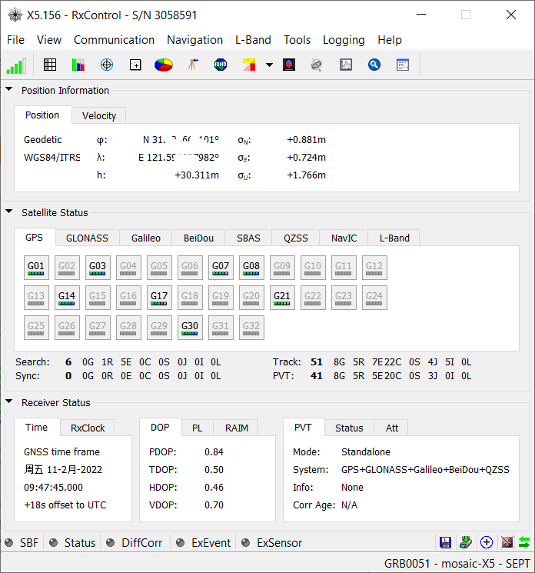

- Open the RxLogger software 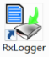to save our data. For the first time opening the software:
- please click on the sub-tab “Global” to set the Log path and the file types to be saved.
- Please select both SBF Messages and NMEA Messages simultaneously.
On the “Status” sub-tab page, click “Start Logging” to begin recording data. Please record at least one minute of data.

- To convert the SBF file format to the receiver-independent RINEX format, please open the SBF Converter.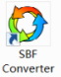 Select the SBF file you generated and check the RINEX output format.
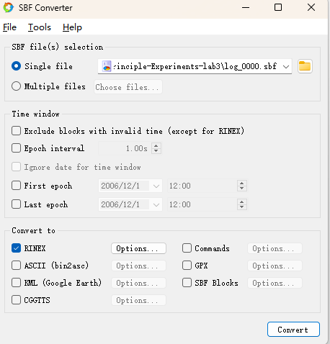
- Click on the Options next to RINEX to configure the specific file format required as the follow figure.

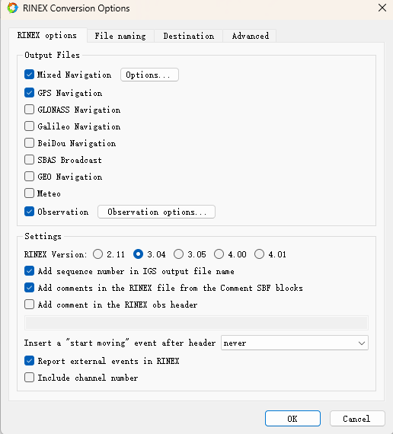

- In this way, we obtain the receiver's navigation file (N file), observation file (O file), multi-system navigation file (P file), and NMEA file. NOTE:The first three are used for high-precision satellite navigation processing, while the latter is used for real-time processing and analysis.

2 Experiment
- Find and open Matlab code in the directory path “lab3 - Code”. This time, we have provided the complete executable parse code of GPS Navigation file and multi-system observation file, with sampled data, ”SEPT0750.25N” and “SEPT0750.25O” for testing.

- Run the “parseRinexNavGPS.m” function using the default filename. Check the output named “navData.mat”. Run the process again using the data you have collected, and check the output again.

- Run the “parseRinexNavObs.m” function using the default filename. Check the output named “obsData.mat”. Run the process again using the data you have collected, and check the output again.

- Attempt to analyze the various sentences in the NMEA file.

